Backup Script Instructions

1. Run the script **from the user’s profile.**
2. You will need a folder in your backup location called **Backups**. If you already have this folder, just answer **Y** to the prompt. If you do not, the next prompt will create this folder.

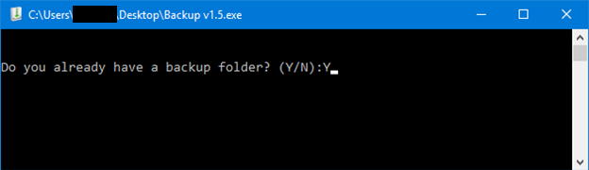

1. Enter the parent folder of your backup location here. In this example, the Backups folder sits at the root of the external E drive. The proper syntax here would be **E:** then hit Enter  
   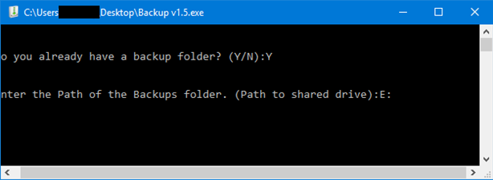
2. The next prompt is a Y/N answer. **DO NOT BACK UP PSTs TO THE N DRIVE OF THE USER**  
   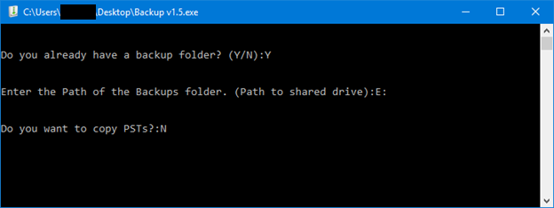
3. The script will now run through and copy the following:

* Desktop
* My Documents
* IE Favorites
* Sticky Notes (if present)
* Office Templates
* Office Queries
* Excel Macros
* PSTs (if selected)
* Signatures
* Chrome Favorites
* Quick Launch Icons
* Startup Items
* Taskbar Layout
* ODBC Connections
* OneNote Notebook Connections (NOT the actual notebooks – My Documents should cover local ones, any others will most likely be on the network)
* Network Printer Connections
* Mapped Drives

1. The final folder will look like this:  
   